Unit 3 Periodic Table
- Alkali Metals-found in group 1 of the periodic table (formerly known as group IA), are very reactive metals that do not occur freely in nature.

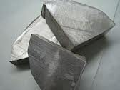
Sodium is an alkali metal.
- Alkaline Earth Metals-The alkaline earth metals are a group of chemical elements in the periodic table with very similar properties: they are all shiny, silvery-white, somewhat reactive metals at standard temperature and pressure
  - 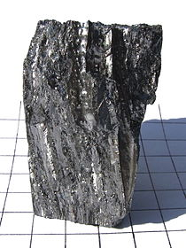
  - Alkaline Earth Metals are not as reactive as Alkali Metals.
- Halogens-The halogens are five non-metallic elements found in group 17 of the periodic table. The term "halogen" means "salt-former"
  - 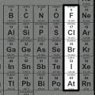
  - Halogens are used in light bulb

- Inner Transition Elements-An inner transition metal is one of a group of chemical elements on the periodic table. They are normally below all of the other elements
  - 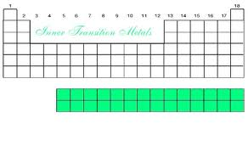
  - Many Inner transition elements are radioactive.
- Lanthanide Series-The lanthanide or lanthanoid series comprises the fifteen metallic chemical elements with atomic numbers 57 through 71
  - 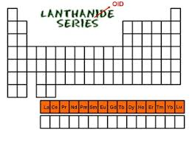
  - The lanthanoid series contains rare earth elements.
- Actinide Series-The actinide or actinoid series encompasses the 15 metallic chemical elements with atomic numbers from 89 to 103
  - 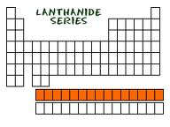
  - The Actinides are denser than the Lanthanides.

- Noble Gas-The Noble Gases. The elements of Group VIII of the Periodic Table are gases which have closed shells and are unreactive chemically.
  - 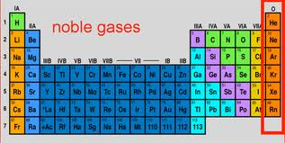
  - The noble gases are known as inert.
- Transition Elements-The transition elements are those elements having a partially filled d or f subshell in any common oxidation state.
  - 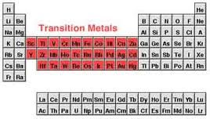
  - Transition elements are metallic.
- Representative elements-The Metallic Elements which are found on the Left side and in the Center of the Periodic Table are Known as Representative Elements.
  - 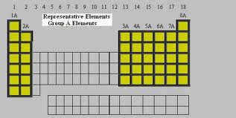
  - Representative elements are found at both end of the periodic table.

- Chemical family-a group (also known as a family) is a vertical column in the periodic table of the chemical elements.
  - 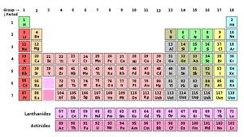
  - There are 18 chemical families on the periodic table.
- Atomic number-The atomic number is equal to the number of protons in an atom's nucleus.
  - 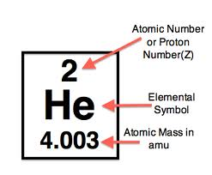
  - The atomic number of Lithium is 3.
- Periodic Table-a tabular display of the chemical elements, organized on the basis of their atomic numbers, electron configurations, and recurring chemical properties.
  - 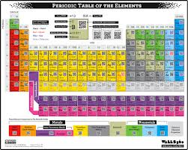
  - The Periodic table currently has 118 elements.

- Protons-a subatomic particle with the symbol p or p+ and a positive electric charge of 1 elementary charge.
  - 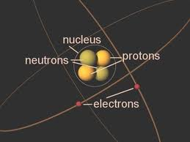
  - Protons are found in the nucleus of an atom.
- Neutrons-a subatomic hadron particle which has the symbol n or n0, no net electric charge and a mass slightly larger than that of a proton.
  - 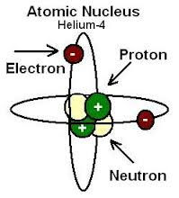
  - The Neutrons are found in the nucleus.
- Electrons-a subatomic particle with a negative elementary electric charge.
  - 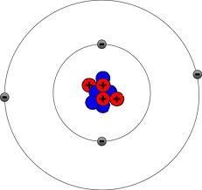
  - Electrons are not found in the nucleus

- Subatomic particle-are the particles smaller than an atom.
  - 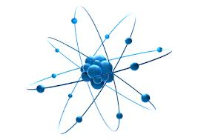
  - Subatomic are electrons, neutrons, and protons.
- Nucleus-very dense region consisting of protons and neutrons at the center of an atom.
  - 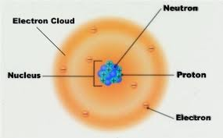
  - The nucleus contains almost all of the atoms mass.
- Electron charge-is a physical property of matter that causes it to experience a force when near other electrically charged matter.
  - 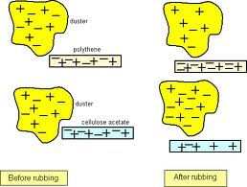
  - Protons are positive, electrons are negative.

- Valence electrons-electrons found in an atoms outermost electron shell.
  - 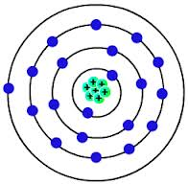
  - The number of valence electrons is equal to the group number.
- Atomic mass- the mass of a specific isotope, most often expressed in unified atomic mass units.
  - 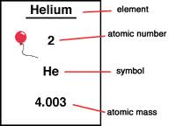
  - Hydrogen’s atomic mass is 1.00794
- Group- A vertical column in the periodic table of the chemical elements.
  - 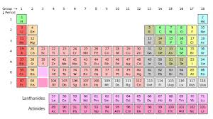
  - There are 18 groups in the periodic table.
- Periods-the 7 horizontal rows in the periodic table.
  - 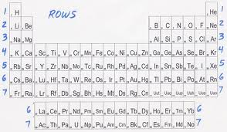
  - Elements in the same group can have similar properties.

- metals- classification for most elements, they have similar properties.
  - 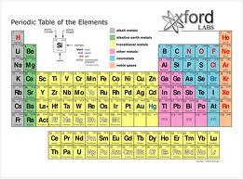
  - Almost everything is made of metals.
- Non-metals-elements that do not have the properties of metals.
  - 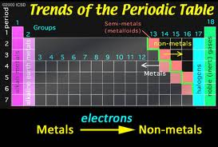
  - Gasses are nonmetals
- Metalloids-elements that are found on the stair step line, have some metal properties, but not enough.
  - 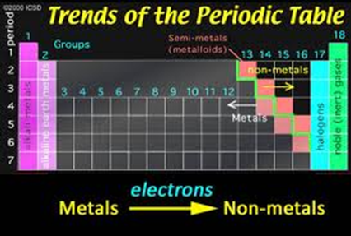
  - There are only 7 metalloids.
- Chemical symbol- a 1-, 2-, or 3-letter internationally agreed code for a chemical element, usually derived from the name of the element, often in Latin.
  - 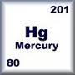
  - Gold’s chemical symbol is Au.

